ANALYST is now variable path-length-diffusive sampler
According the paper published by C. Perrino and M. Catrambone (Atmospheric Environment, 38 (2004), 6667-6672, it is possible to change the diffusive path-length of an Analyst passive sampler by simply inserting spacers In order to reduce the distance between the active surface and the external air. Jn this way, modulation in the diffusive sampling flow rate can be easily achieved. Taking Ammonia as an example, while standard Analyst sampling flow rate is in the order of about 20 ml/min, when reducing the effective diffusive path-length, this figure may be increased up to almost 60 ml/min. This means that the time necessary to detect a given Ammonia concentration can be reduced by a factor of 3 or, assuming the same exposition time, the achievable concentration can be reduced by a factor of 3. This is taking into account that the limiting factor is still the field blank value of the passive sampler. According to the detection limits, defined as 2σ of the field blanks, they are now of the order of 0,1 µg which means a minimum detectable concentration of 1,2 µg/m3 for one day exposure and 0,15 µg/m3 for a week exposure when the configuration with the shortest diffusive pathway (8mm) is used. In the cited paper, a series of experimental measures confirmed the stability of the passive sampling procedures and the achievement of results predicted by the diffusive theory. Now ENVINT performed specific field experiments and was able to reproduce such good results. As a consequence, ENVINT is now pleased to discuss with potential customers the adaptation of standard ANALYST passive samplers to shorter diffusive path-lengths without any additional cost. This new ANALYST model will be available on Jan. 1st, 2019.
www.envint.it info@envint.it

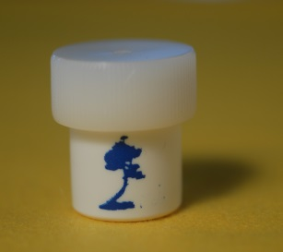
Standard ANALYST Passive Sampler for Ammonia
L=25 mm
Φ=20 mL/min
High Diffusion Flow Rate ANALYST Passive Sampler
L=8 mm
Φ=57 mL/min
L=12 mm
Φ=39 mL/min
Active Surface

