2-3 March 2017 – Improving Regionalk Air Quality in China
(See file)

4-6 May 2017 - Trade fair for environmental technology solutions, Shanghai (China)
Participation to this exhibition has been promoted by the Italian Ministry for the Environment, Land and Sea (IMELS). ENVINT presented technologies related to passive sampling. Analyst passive samplers and applications were displayed and discussed with Chines companies

13-16 June, 2017 - CIEPEC 2017 Beijing (China)
The exhibition has been organised to promote innovative Italian technologies, equipment and services in the field of environmental protection, and help Italian enterprises to penetrate into the Chinese market. CIEPEC is in the framework of the collaboration with the Chinese Ministry of Environmental Protection (MEP), and the Italian Ministry for the Environment, Land and Sea (IMELS). ENVINT participated to the exhibition with Italian companies engaged into the PM2,5 project with the BJEMC (Beijing Environmental Monitoring Centre).

8 November 2017 – ECOMONDO 2017 Rimini (Italy)
ENVINT participated to the workshop “Indoor air quality” organised within ECOMOINDOI 2017. The workshop was addressed to problems related to indoor air quality. In the poster session, ENVINT presented the automatic sampler specifically for the controlled exposure of ANALYST passive sampler PAS 06/15.
(See File)

25 October 2017 CE Certification for PAS 06/15
OCE (European Certification Body) release the test report number 173L/2017 according to which ENVINT PAS 06/15 passed tests for Electromagnetic Compatibility compliance test of the emission and immunity. This certification, known as CE, is the first step toward the international market for this apparatus. PAS 06/15 is intended for the automatic controlled exposition of ANALYST passive samplers, thus is it able to fill gaps inherent passive sampling strategy.

4-6 October 2017 19 International Symposium MESAEP
CNR hosted the 19th International Symposium on “Environmental Pollution and its Impact on Life in the Mediterranean Region” organised by MESAEP (Mediterranean Scientific Association of Environmental Protection). The conference was addressed to several topics related to the environment in Mediterranean area, including indoor and outdoor pollution. ENVINT participated to the scientific program with an oral communication on “A new device for automatic sampling of passive samplers to monitor air pollution”. (See presentation in “papers”

15 January 2018 – Monitoring diffuse emissions in refineries
US Environmental Protection Agency issued a regulation according to which by 2019 refineries will be required to measure diffuse Benzene emissions along the fenceline. EPA requires industries to reduce emissions from flares, storage tanks, delayed coking units, and implement fence line monitoring of Benzene. Among other analytical methods, passive sampling is considered as the most suitable for this purpose. ANALYST passive samplers are very suitable for such an application and may be adapted to measure several other species in addition to Benzene. Details are available on http://www.regulations.gov/#!documentDetail;D=EPA-HQ-OAR-2010-0682-0700 copy of which is reported and can be downloaded in “documents”

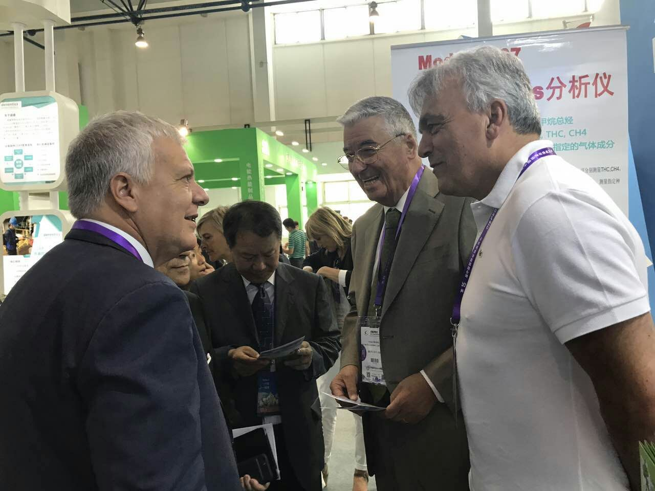

Enrico Bompadre of FAI instrument and Ivo Allegrini of ENVINT explain to Mr. Galletti, Minister for the protection of Environment, Land and Sea, technical achievements shown at the CIEPEC 2018 exhibition.

